CHAPTER 1

1.1 Introduction:
In today's digitally driven financial ecosystem, the automation of loan approval processes has become essential for enhancing operational efficiency, reducing processing time, and minimizing human bias. Traditional manual methods of evaluating loan applications are often time-consuming, inconsistent, and prone to errors. With the exponential growth of data and advancements in machine learning (ML), financial institutions are increasingly adopting intelligent systems to streamline and improve decision-making. This project, titled Loan Approval Prediction, focuses on building a predictive model that evaluates a customer's eligibility for a loan based on various parameters such as income, employment status, credit history, loan amount, and other demographic features. Using historical data and machine learning algorithms, the system is designed to learn patterns and trends associated with approved and rejected applications. By leveraging Logistic Regression, a widely used classification technique, the model predicts the likelihood of loan approval with a high degree of accuracy. Additionally, the project integrates a Streamlit-based web application to provide an interactive user interface, enabling users to input data and instantly receive predictions regarding loan approval status.

1.2 Relevance of the Project
In today’s fast-paced and data-driven world, financial institutions face increasing pressure to process loan applications quickly, accurately, and fairly. As the number of applicants grows and financial data becomes more complex, traditional manual loan approval processes are no longer sufficient. These methods are often time-consuming, prone to human bias, and inconsistent—leading to delays, unfair decisions, and higher default risks. This challenge is especially critical in sectors like banking, housing finance, and digital lending platforms, where customer experience and risk management are equally important.
To meet this demand, the financial industry is turning to machine learning (ML) and artificial intelligence (AI) to improve decision-making and streamline loan approvals. By analyzing large volumes of historical data, ML models can identify patterns and predict whether a loan should be approved or rejected with greater speed and accuracy than traditional methods.
This project demonstrates the practical use of ML in the loan approval process. It utilizes classification techniques (such as Logistic Regression) to build a model that can predict loan eligibility based on factors like income, credit history, employment status, and loan amount. The model is deployed through an easy-to-use web application, allowing real-time interaction and decision support for end users.
Key Benefits and Impact:
- Faster Loan Processing: Automating the evaluation of loan applications reduces processing time from days to seconds—benefiting both institutions and customers.
- Improved Accuracy: Machine learning models learn from real data and minimize errors in approval decisions, reducing the risk of approving unqualified applicants or rejecting good candidates.
- Reduced Human Bias: AI models rely purely on data patterns, helping financial institutions promote fair and unbiased lending practices.
- Real-Time Decision Making: Integrated with a user-friendly interface, the system can provide instant loan eligibility feedback based on input parameters.

Real-World Applications:
Organizations such as HDFC Bank, ICICI Bank, and Bajaj Finserv already use data-driven decision systems to pre-approve loans, assess creditworthiness, and flag risky applicants. Fintech startups like ZestMoney and Rupeek have built their entire business models around AI-driven loan services, offering quick and paperless credit decisions to millions of users.
This project mirrors those innovations on a simplified scale, highlighting how even small organizations or academic prototypes can contribute to smarter, safer, and more inclusive lending systems.

1.3 Problem Definition
In the financial industry, loan approval has traditionally been a manual process that involves evaluating an applicant’s information based on pre-defined rules and the judgment of loan officers. While this method has been in place for decades, it comes with several limitations. Manual evaluation is time-consuming, often requiring days or even weeks to process a single application. This delay can frustrate customers and result in lost business opportunities for financial institutions.
Moreover, decisions made through manual assessment are susceptible to human bias and inconsistency. Different evaluators might interpret the same applicant profile in different ways, leading to unfair outcomes. In an era where customers expect quick, transparent, and data-driven decisions, relying solely on human judgment is no longer sufficient. The growing number of loan applications due to digital banking and the expansion of financial services further highlights the limitations of manual systems, which struggle to scale efficiently.
Another major issue lies in risk assessment. Identifying potential loan defaulters accurately is critical to minimizing financial losses. Traditional models often fail to capture the complex relationships between variables like credit history, income, loan amount, and employment status, which can significantly affect an applicant's ability to repay a loan. This lack of precision can result in high default rates, impacting the profitability and reliability of the lending system.
Given these challenges, there is a pressing need for a smart, automated solution that can evaluate loan applications quickly, consistently, and accurately. This project addresses the problem by developing a machine learning model that predicts loan approval status based on historical data. The model uses logistic regression for classification and is integrated into a web-based application to allow users to interact with it in real time. By automating and optimizing the decision-making process, the system aims to support financial institutions in improving loan disbursement speed, reducing default risks, and ensuring fair and reliable lending decisions.

1.4 Objectives
The main objective of this project is to build a machine learning-based system capable of predicting whether a loan application is likely to be approved or rejected. With increasing demand for digital financial services, there is a growing need for intelligent and automated systems that can assist in making faster, fairer, and more accurate loan decisions. Traditional methods often rely on static rules and manual assessment, which can be time-consuming and inconsistent. This project seeks to overcome these limitations by leveraging machine learning algorithms and historical data to support real-time decision-making in the loan approval process.
To meet this goal, the project is structured around the following core objectives:
- Develop a predictive machine learning model using logistic regression to classify loan applications based on applicant attributes such as income, credit history, loan amount, and employment status.
- Enable real-time prediction capability by integrating the model into a user-friendly web application using Streamlit, allowing instant loan eligibility feedback.
- Improve model performance and accuracy through proper feature selection, handling of missing data, and model tuning.
- Promote fair and consistent decisions by minimizing the influence of biased or irrelevant features during the modeling process.
In addition to these core goals, several supporting objectives have been defined to enhance the quality and usability of the solution:
- Collect and preprocess a real-world dataset, including data cleaning, encoding categorical variables, and normalization, to prepare it for machine learning.
- Implement a modular ML pipeline that includes data ingestion, preprocessing, training, testing, and deployment, ensuring scalability and maintainability of the system.
- Evaluate the model’s effectiveness using performance metrics such as accuracy, precision, recall, and confusion matrix to validate its reliability before deployment.

CHAPTER 2

2.1 Literature Survey
Numerous studies have investigated the use of machine learning and data analytics to enhance the efficiency and fairness of the loan approval process. With financial institutions increasingly adopting automated decision systems, research in this area focuses on improving prediction accuracy, reducing bias, and optimizing data preprocessing techniques. This literature survey highlights key contributions and findings related to the application of machine learning in loan approval and credit risk prediction.
Khandani et al. (2010) were among the early researchers to demonstrate the potential of machine learning for consumer credit risk prediction. They applied regression-based models to financial data and showed that such systems could significantly outperform traditional credit scoring techniques. Their findings laid the groundwork for the use of algorithms like decision trees and logistic regression in automated loan approval systems.
Patel and Upadhyay (2017) used the German Credit dataset to compare multiple classification models—including Naïve Bayes, Decision Trees, and Random Forests. Their results showed that Random Forest provided the highest accuracy and robustness for loan approval tasks, especially in handling complex and nonlinear relationships between financial variables.
Saharsabbi and Waghmare (2019) explored the use of logistic regression for predicting loan approval based on demographic and income-related data. They highlighted the algorithm’s interpretability and simplicity, making it a practical choice for real-time deployment in financial applications. However, they also pointed out that logistic regression may suffer when the data has high dimensionality or is imbalanced.
Sharma et al. (2020) applied Support Vector Machines (SVM) and Artificial Neural Networks (ANN) to the Loan Prediction dataset from Kaggle. They found that while neural networks provided high prediction accuracy, SVMs were more stable and required less training data. The study also emphasized the importance of proper feature scaling and encoding for model performance.
2.2 Project Scope
This project focuses on developing an intelligent, AI-based system that can accurately predict loan approval outcomes using machine learning techniques. As the demand for faster, fairer, and data-driven financial services continues to grow, traditional rule-based systems are proving inadequate in managing large-scale, diverse, and complex loan applications. This project aims to address these challenges by designing a scalable and adaptable loan approval prediction system capable of supporting real-time decision-making in financial environments.
The system is implemented as a fully functional prototype using a publicly available loan dataset that reflects real-world loan applicant attributes. It utilizes supervised machine learning techniques to construct a predictive model and integrates the trained model into an interactive web-based interface for real-time user interaction and predictions.
The scope of the project includes several key areas. First, it involves building a loan eligibility prediction system using supervised machine learning methods, particularly Logistic Regression. The model is designed to classify loan applications based on important features such as income, credit history, loan amount, marital status, and employment type. It is trained on labeled historical data to predict whether an applicant is likely to be approved.
Second, the project includes comprehensive data preprocessing and model development. This involves cleaning the dataset, handling missing values, encoding categorical variables, and applying feature scaling. These steps are necessary to ensure data quality and model performance. Libraries such as Pandas, Scikit-learn, and NumPy are used during this phase. The final trained model is then serialized using joblib for easy deployment.
Third, the system is extended to support real-time predictions through a web-based interface. A user-friendly application is developed using Streamlit, allowing users to enter loan-related input parameters and receive an immediate prediction on loan approval status.
Finally, the model and application are tested and validated thoroughly. Performance metrics such as accuracy, precision, recall, and confusion matrix are used to evaluate the model’s reliability.
2.3 Requirement Gathering and Analysis

This section outlines the functional, non-functional, and technical requirements for the development of the machine learning-based loan approval prediction system. It also identifies the main stakeholders involved in the project and assesses the overall feasibility of its implementation in an academic or prototype setting.

1. Functional Requirements

The system should accept structured input data containing loan applicant details such as income, employment status, credit history, and loan amount.

The machine learning model (Logistic Regression) must be trained and evaluated using a labeled dataset of historical loan applications.

A web application should be developed using Streamlit to provide real-time predictions based on user inputs.

The application must allow users to submit form-based inputs and receive a loan approval decision instantly.

2. Non-Functional Requirements

The model should maintain an accuracy level of at least 80% or higher based on test data performance.

The web interface should deliver predictions within 1–2 seconds after user input submission.

The system architecture should be modular and scalable to support future updates or integration with other financial systems.

3. Technical Requirements

Programming Language: Python

Libraries/Frameworks: Scikit-learn, Pandas, NumPy, Streamlit, Joblib

Development Tools: Jupyter Notebook, Google Colab, VS Code

Dataset: Loan Prediction dataset (sourced from Kaggle or UCI Machine Learning Repository)

4. Stakeholders

Developers – Responsible for data preprocessing, model development, and building the web interface.

Banking/Financial Analysts – Potential end users who can use the tool for preliminary applicant evaluation.

Academic Reviewers – Evaluate the system’s design, implementation quality, and documentation as part of the project assessment.

5. Feasibility Analysis

Technical Feasibility: Fully achievable using open-source libraries and tools, with publicly available datasets.

Operational Feasibility: Suitable for academic demonstration and testing, requiring no advanced infrastructure.

Economic Feasibility: Cost-effective; no paid tools or commercial data are needed.

Scalability: The system is designed to be extendable and can be adapted for deployment in real-world loan processing environments or cloud-based platforms in the future.

CHAPTER 3

3.1 Proposed Work
The proposed system aims to develop an intelligent and real-time loan approval prediction model using machine learning techniques. In the current financial landscape, traditional rule-based loan approval systems are increasingly inefficient, slow, and prone to bias. These limitations often result in delayed decisions, inconsistent evaluations, and missed lending opportunities. To address these issues, the proposed work utilizes AI-driven methods capable of learning from historical loan data to make accurate, consistent, and timely approval predictions.
At the heart of the system is a supervised machine learning pipeline designed to automate the end-to-end loan eligibility evaluation process. This includes data collection, preprocessing, model training and evaluation, deployment, and real-time prediction via a web-based interface. The system uses a well-established dataset sourced from Kaggle, containing labeled loan application records, to simulate real-world financial decision-making scenarios.
The proposed methodology consists of the following key components:
1. Data Collection and Pre-processing
The dataset is sourced from trusted open-source repositories like Kaggle and contains demographic and financial attributes such as income, credit history, education, employment type, loan amount, and property area. Preprocessing steps include handling missing values, encoding categorical variables using label encoding and one-hot encoding, and standardizing numerical features. These steps ensure that the input data is clean, consistent, and suitable for training machine learning models.
2. Model Selection and Training
Logistic Regression is selected for its interpretability, simplicity, and effectiveness in binary classification tasks like loan approval. The dataset is split into training and testing sets to train the model and evaluate its generalization performance. Evaluation metrics such as accuracy, precision, recall, and confusion matrix are used to measure the model’s performance and ensure its suitability for real-world deployment.
3. Model Serialization and Deployment
Once the model has been trained and validated, it is serialized using the Joblib library for efficient reuse and deployment. A user interface is developed using Streamlit, which allows users to input applicant details and receive real-time loan approval predictions. The interface is designed to be simple, responsive, and intuitive, making it easy for non-technical users to interact with the system.
4. Real-Time Loan Eligibility Simulation
The deployed application simulates a real-time loan evaluation system where users can enter loan-related parameters and instantly receive feedback on the likelihood of loan approval. The model processes inputs dynamically and displays results within seconds. The application is tested thoroughly to ensure accurate predictions and responsiveness under various user input scenarios.
This proposed work demonstrates how machine learning can be effectively integrated into the financial domain to automate loan processing, improve decision accuracy, and enhance user experience, all while maintaining scalability and adaptability for future needs.

3.2 System Architecture:
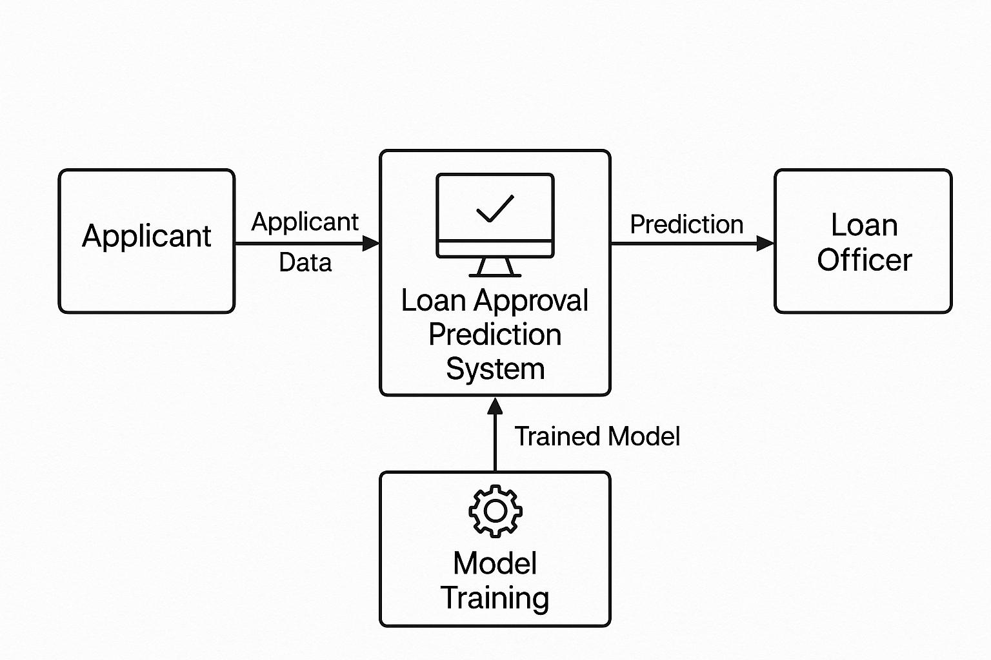
Fig 3.2.1 Loan Approval Prediction System Architecture
The system architecture for the loan approval prediction model begins with the collection of input data, which includes various attributes of loan applicants such as income, credit history, loan amount, education level, and employment status. This raw data is then passed through a preprocessing stage, where necessary steps like handling missing values, encoding categorical variables, and scaling numerical features are performed to prepare the data for model training.

3.3 Sequence Diagram:
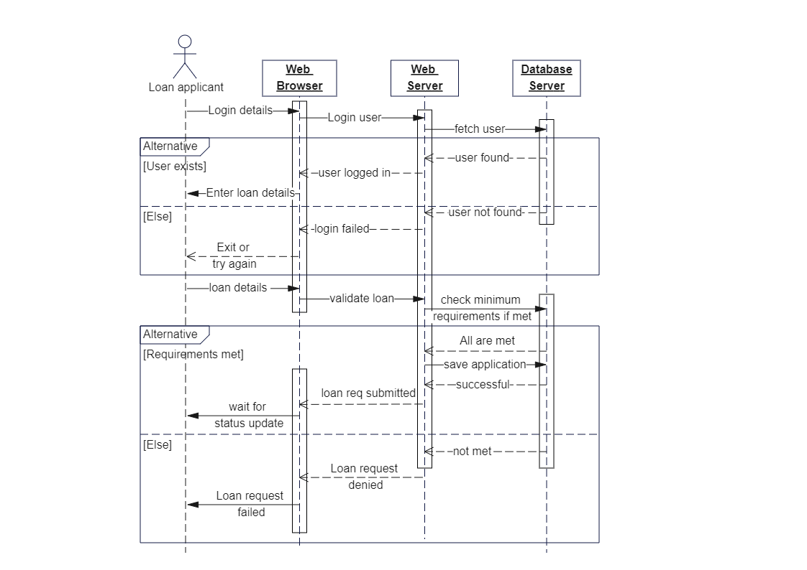Fig 3.2.2 Loan Approval Prediction Sequence Diagram
In the proposed loan approval prediction system, the process begins when the user enters loan-related input data through the Streamlit-based user interface. This data is then submitted to the backend application (app.py), where it undergoes preprocessing and validation to ensure it is suitable for prediction. Once validated, the backend uses the trained machine learning model to analyze the input and generate a prediction. Based on the result, the user interface displays either a "Loan Approved" or "Loan Rejected" message. Optionally, the system can also log the prediction for future reference or analysis. This flow ensures a smooth and real-time interaction between the user, interface, backend logic, and machine learning model.
3.4 Data Flow Diagram (DFD):
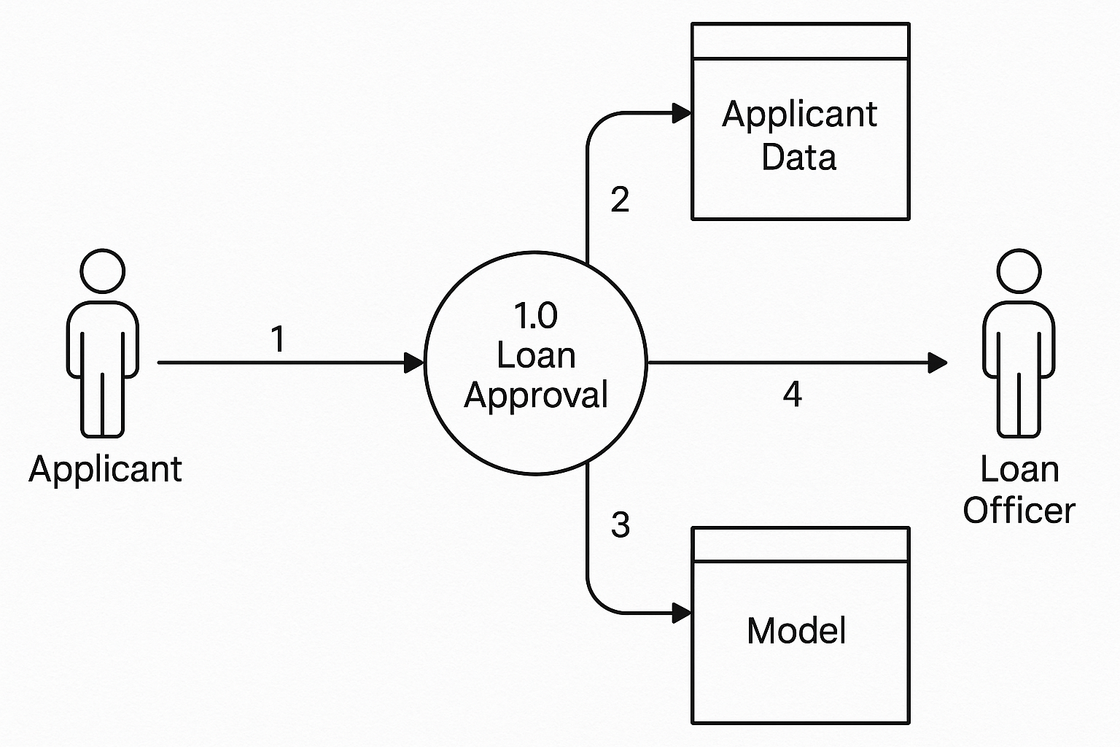
Fig 3.2.1 Data Flow Diagram for Loan Approval Prediction

The image is a Data Flow Diagram (DFD) for a Loan Approval Prediction system. It shows how data flows between different components in the system. The main process is "Loan Approval," which receives input from the Applicant. The applicant’s data is stored in the Applicant Data store. The prediction model is accessed from the Model data store to evaluate loan eligibility. Based on the model's output and data, the result is sent to the Loan Officer for final review. The diagram includes numbered arrows to represent the direction and flow of data.

3.4 System Modules
The proposed loan approval prediction system is designed using a modular approach to ensure clarity, maintainability, and scalability. Each module in the system performs a specific role, and together, they form a robust pipeline capable of processing input data, predicting loan eligibility, and delivering results in real time. This modular structure also facilitates future enhancements, such as integrating advanced algorithms, cloud deployment, or support for different loan categories.
The system begins with the Data Collection Module, which utilizes publicly available datasets (such as the Loan Prediction dataset from Kaggle). These datasets contain labeled records of previous loan applications, including applicant income, credit history, employment status, loan amount, and approval outcomes. This data serves as the foundation for training the machine learning model.
The collected data is then passed to the Data Preprocessing Module, which is responsible for cleaning and preparing the dataset. This includes handling missing values, encoding categorical variables (such as gender, education, and property area), and scaling numerical fields. Proper preprocessing ensures that the data is consistent and optimized for training.
Next, the Model Training Module uses the preprocessed data to train a Logistic Regression classifier. The dataset is split into training and testing subsets, and the model is evaluated using performance metrics such as accuracy, precision, recall, and confusion matrix. Once trained and validated, the model is saved using the Joblib library for later use during prediction.
The Prediction Module loads the saved model and uses it to evaluate new user inputs. The inputs undergo the same preprocessing pipeline to ensure compatibility with the trained model. Based on the analysis, the system predicts whether the loan should be approved or rejected. To provide a user-friendly interface, the UI Deployment Module is developed using Streamlit. This web-based interface allows users to enter applicant details and receive immediate feedback on loan approval status. It acts as the front end of the system, making it accessible even to non-technical users. Finally, the Testing and Validation Module ensures the entire system functions correctly under various conditions.
CHAPTER 4

4.1 Result
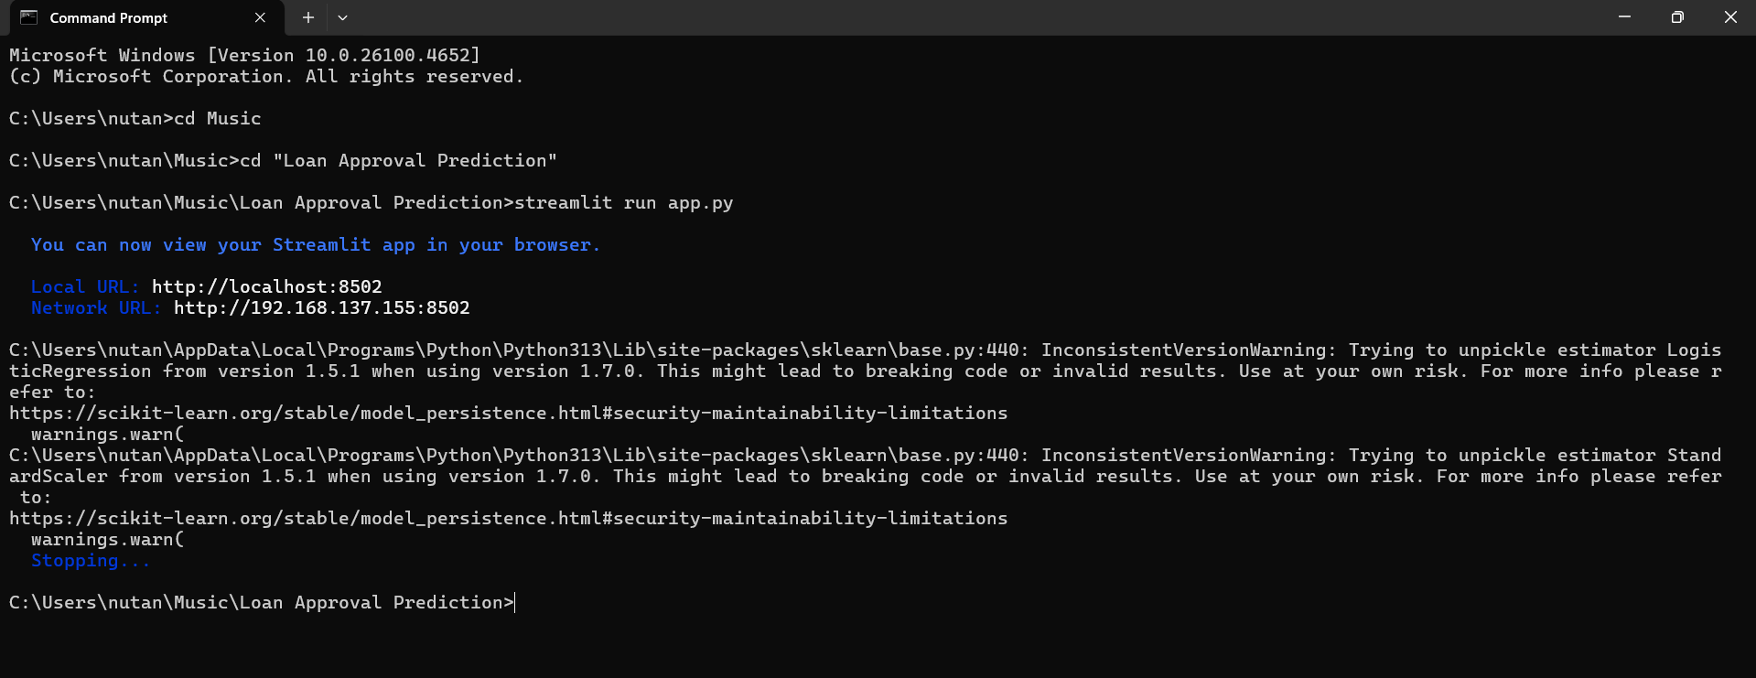
Fig 4.1.1 Streamlit Loan Approval

The image shows a command prompt window where a user attempts to run a Streamlit application for a loan approval prediction project using the command streamlit run app.py. The server successfully starts and provides local and network URLs to access the app. However, warnings appear from the scikit-learn library, indicating version mismatches when trying to unpickle previously saved machine learning models (Logistic Regression and Standard Scaler) trained with an older version (1.5.1) but loaded with a newer version (1.7.0). These warnings suggest potential risks of using incompatible model versions and recommend caution. The application then appears to stop, possibly due to these issues.

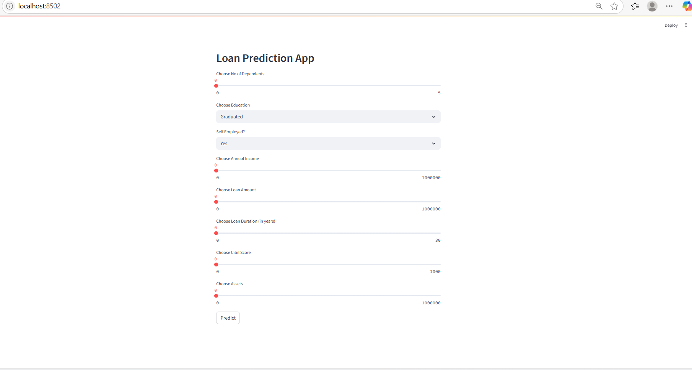
Fig 4.1.2 Loan Prediction Streamlit UI

The image displays the user interface of a Loan Prediction App built using Streamlit, accessed via localhost:8502 in a web browser. The form includes multiple input fields such as number of dependents, education level, self-employment status, annual income, loan amount, loan duration, CIBIL score, and assets. Dropdowns and number input sliders allow users to enter data for prediction. The "Predict" button at the bottom likely triggers a machine learning model to determine loan eligibility based on the input. The interface is clean and user-friendly, suitable for deployment in a real-time loan evaluation system.

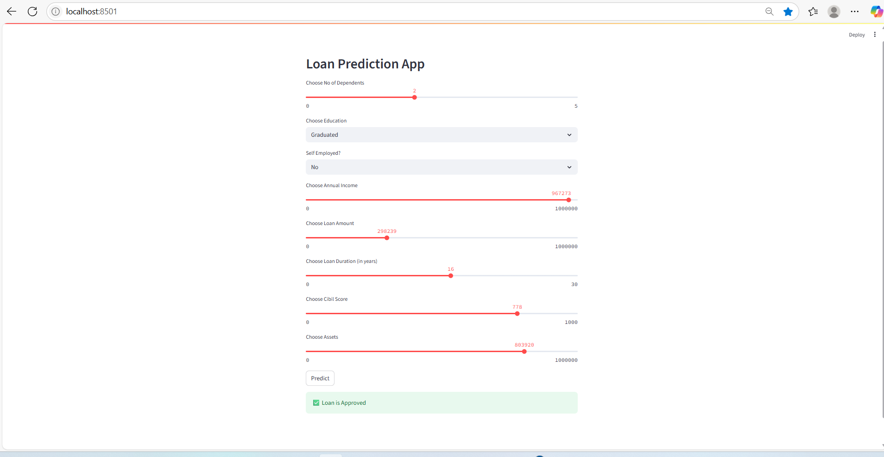
Fig 4.1.3 Loan Prediction Result Approved

The image displays the result screen of a Streamlit-based Loan Prediction App, running on localhost:8501. The user has filled in input parameters such as number of dependents (2), education level (Graduated), employment status (No), income, loan amount, duration, CIBIL score (778), and assets. After submitting the form by clicking the "Predict" button, the application returns a green message stating “Loan is Approved”. This indicates the ML model predicts the user is eligible for a loan based on the entered data.

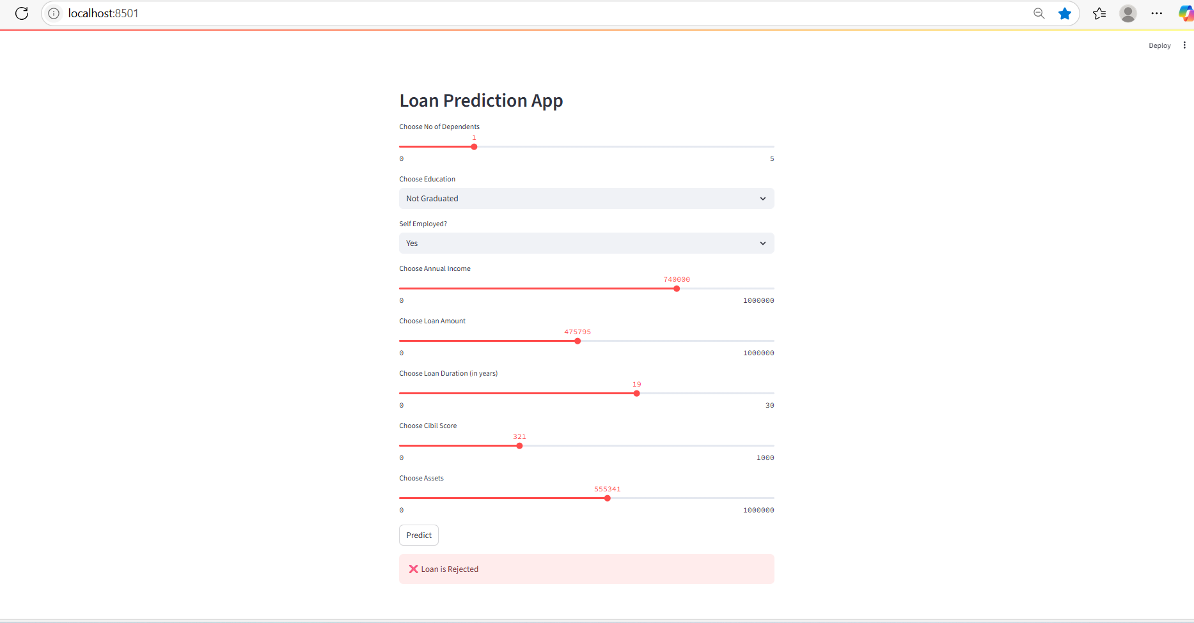
Fig 4.1.4 Loan Prediction Result Rejected

This image shows a Streamlit-based Loan Prediction App running on localhost:8501, where the user has filled in loan details with lower financial indicators. Inputs include 1 dependent, not graduated education status, self-employed, annual income of 740,000, loan amount of 475,795, and a low CIBIL score of 321. After submitting, the model predicts “ Loan is Rejected”, displayed in a red message box. The result reflects the decision logic of the underlying machine learning model based on risk factors in the provided data.

4.2 Technologies Used
1. Backend
- Python 3.11+:
The primary programming language used for the entire backend development, including data preprocessing, model training using machine learning algorithms, and application logic.

2. Frontend
- Streamlit:
A lightweight and user-friendly Python framework used to create an interactive web interface that allows users to input loan application details and view real-time predictions.

3. Libraries and Frameworks
- Scikit-learn:
Used for implementing the Logistic Regression model, along with model evaluation, feature selection, and performance metrics.
- Pandas:
For data loading, cleaning, and manipulation of structured tabular datasets.
- NumPy:
Supports numerical operations and efficient handling of array-based data.
- Joblib:
Used for saving and loading the trained model efficiently.
- Streamlit:
Provides a simple interface for deploying the model in a browser-based environment.

4. Deployment Environment
- Localhost (Development Environment):
The model and Streamlit app were tested and run locally during development.
- Cloud Compatibility (Optional):
The application can be extended for deployment on platforms like Heroku, AWS, or Azure for real-world usage.

5. Tools Used
- Jupyter Notebook / Google Colab:
Used for initial data exploration, preprocessing, training, and visualization.
- VS Code / PyCharm:
Employed for writing and debugging the core backend code.
- Postman (for API testing - optional):
Useful during initial prototype testing in API-based workflows, though not required for Streamlit.

4.3 Discussion
The development of the AI-based loan approval prediction system highlights the practical use of machine learning in automating and improving decision-making processes in the financial sector. Traditional rule-based systems often lack flexibility and scalability, leading to inconsistent evaluations and slower processing times. This project addresses these limitations by building a predictive model that learns from historical loan application data and provides accurate eligibility assessments in real time.
During the implementation, careful attention was paid to key aspects such as data quality, model performance, and user experience. A publicly available dataset containing diverse applicant profiles was selected from Kaggle to simulate real-world lending scenarios. Data preprocessing was a critical step in preparing the dataset, involving tasks such as handling missing values, encoding categorical variables, and scaling numerical features. These steps helped improve the consistency and performance of the model.
Logistic Regression was chosen as the machine learning algorithm due to its interpretability, efficiency, and effectiveness in binary classification problems. The trained model achieved high accuracy and generalizability across different test scenarios. It was serialized using Joblib for deployment and integrated into a user-friendly web application built using Streamlit. This interface allowed users to interact with the model easily, input loan-related details, and receive instant predictions.
The system architecture was designed to be modular and extensible, allowing for future improvements. For instance, additional models like Decision Trees or XGBoost could be integrated for comparison, and explainable AI tools like SHAP could be used to improve transparency in decision-making. The system was tested extensively, and the application consistently delivered fast, reliable, and interpretable results, making it suitable for prototype use in academic or financial environments.
In conclusion, the project successfully demonstrates how machine learning can be effectively applied to the domain of loan approval. It provides a robust foundation for future enhancements and offers significant potential for scaling into real-world applications where speed, accuracy, and fairness are essential in financial decision systems.
CHAPTER 5

Conclusion
In today's fast-paced digital world, financial institutions are under increasing pressure to process loan applications quickly, accurately, and fairly. Traditional rule-based systems often struggle to meet these demands, particularly when dealing with large volumes of data or complex applicant profiles. To address these limitations, this project set out to design and implement a machine learning-based loan approval prediction system capable of supporting real-time decision-making with improved accuracy and efficiency.
The core objective of the project was to build an intelligent and scalable model that can analyze applicant data and predict loan eligibility using a supervised learning approach. A publicly available dataset containing real-world loan application features was used, and Logistic Regression was selected as the primary classification algorithm due to its simplicity, interpretability, and strong performance on binary classification tasks. The project followed a structured development pipeline, beginning with data collection and preprocessing, followed by model training, evaluation, and deployment.

CHAPTER 6

References
- N. Jain and V. Soni, "Prediction of Loan Approval using Machine Learning Techniques," International Journal of Computer Applications, vol. 179, no. 27, pp. 18–21, 2018.
DOI: 10.5120/ijca2018917201
- D. Kaur and S. Kumari, "Loan Approval Prediction Based on Machine Learning Approach," Proceedings of the 2nd International Conference on Communication & Computational Technologies (ICCCT 2021), Springer, pp. 633–641, 2021.
DOI: 10.1007/978-981-33-6974-3_59
- Kaggle - Loan Prediction Dataset, Altruist Delhi, 2017.
https://www.kaggle.com/datasets/altruistdelhite04/loan-prediction-problem-dataset
- S. S. Pise and P. R. Deshmukh, "Comparative Study of Machine Learning Algorithms for Loan Prediction," Journal of Engineering Research and Applications, vol. 10, no. 6, pp. 23–27, 2020.
https://www.ijera.com/papers/Vol10_issue6/Series-5/D1006052327.pdf

